RZSS Koala Activity Study:
How To Do A Behaviour Study At Home

Task

We all know koalas sleep a lot. This species sleep over 16 hours a day! But have you ever wondered whether a koala is nocturnal? This worksheet will guide you through how you can find out for yourselves using the RZSS webcams! Here are the resources you will need:

Resources

- Ethogram (provided)
- Datasheet (provided)
- Koala Webcam: https://www.edinburghzoo.org.uk/webcams/koala-cam/#koalacam

Research Question: What time of day are Koalas most active?

Hypothesis: You tell us!

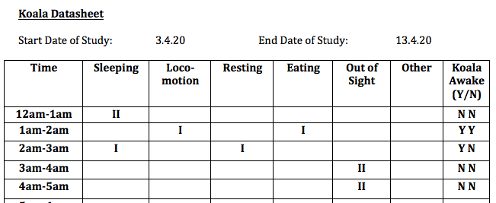
What To Do:

Use the datasheet provided to record the behaviour of the koala at different times of day. You need not stay up for 24 hours in a row, but instead can collect the data over a week or more. Try to ensure that you have recorded the behaviour at least twice for each hour of the day. You will notice that the webcam does not work throughout the night. By conducting this study, you will also be able to identify what hours the webcam is active. You need not do an observation over several minutes but instead need only note what the koala is doing once as and when you log on. The more you log on to record data, the more representative your data will be of the koalas true behaviour.

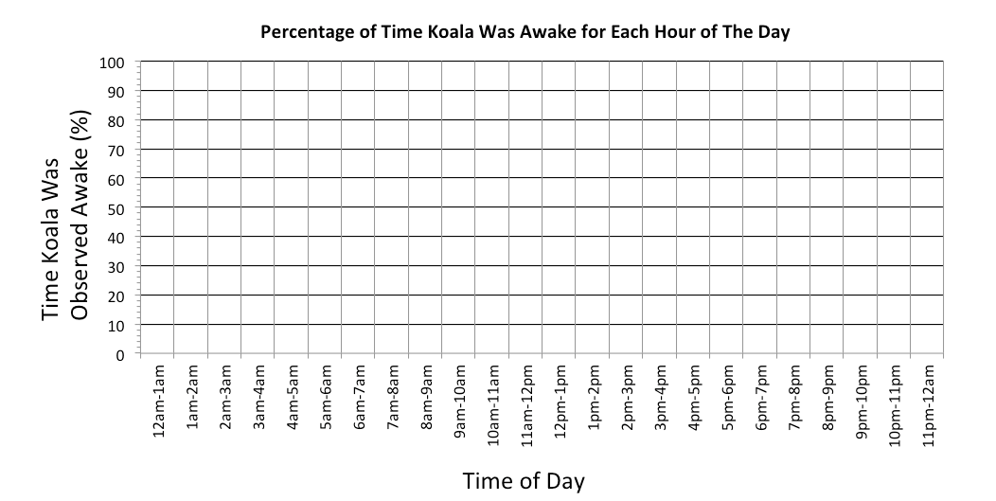
Graphing the Data:

For each hour of the day, calculate the percentage of times the koala was seen awake.

Complete this blank graph to display the results of your behaviour study.

Koala Ethogram

Behaviour | Definition | Behaviour | Definition
Sleeping | Koala is not moving. Head is angled down & eyes closed. | Locomotion | Koala is moving from A to B using its hands and feet.
Resting | Koala is not moving. Head is not angled down & eyes open. | Eating | Koala is ingesting food with its mouth with use of hands.
Out of Sight | Koala is located in an area not visible to the researcher. | Other | Note down any other behaviour shown by the koala.

Koala Datasheet

Start Date of Study: End Date of Study:

Time | Sleeping | Loco-motion | Resting | Eating | Out of Sight | Other | Koala Awake (Y/N)
12am-1am
1am-2am
2am-3am
3am-4am
4am-5am
5am-6am
6am-7am
7am-8am
8am-9am
9am-10am
10am-11am
11am-12pm
12pm-1pm
1pm-2pm
2pm-3pm
3pm-4pm
4pm-5pm
5pm-6pm
6pm-7pm
7pm-8pm
8pm-9pm
9pm-10pm
10pm-11pm
11pm-12am

